Project Plan

for the

Construction Department of Southern Illinois University Edwardsville

by

Bryan Allen – Quality Assurance

Daniel Grote – Customer Representative

Zach Smith – Scrum Master

of

CS425 / CS499 Senior Project

Concrete Drying Application Team

CS-PLAN

Revision 1.0.3

As Of: 16 March 2015

**Change Log:**

|  |  |
| --- | --- |
| Revision | Change Note(s) |
| 1.0.1 | Made modifications for sprint 1 preparation phase, and made changes as suggested by Dr. Mayer |
| 1.0.2 | Removed usability study and updated sprint schedule |
| 1.0.3 | Updates risks, schedule, and testplan. |

Table of Contents

1 Estimation 1

2 Resources 1

3 Scheduling 2

4 Communication 3

5 Quality Assurance 3

6 Exit Strategy 5

6.1 425 Exit Strategy 5

6.2 499 Exit Strategy 6

**Figures**

Figure 1: High Level Architecture ............................................................................................................................... 1 Figure 2: Schedule .............................................................................................................................................................. 2

**Tables**

Table 1: Resources ............................................................................................................................................................. 2

Table 2: Risk Table ............................................................................................................................................................ 3 Table 3: Test Plan ............................................................................................................................................................... 4

# Estimation

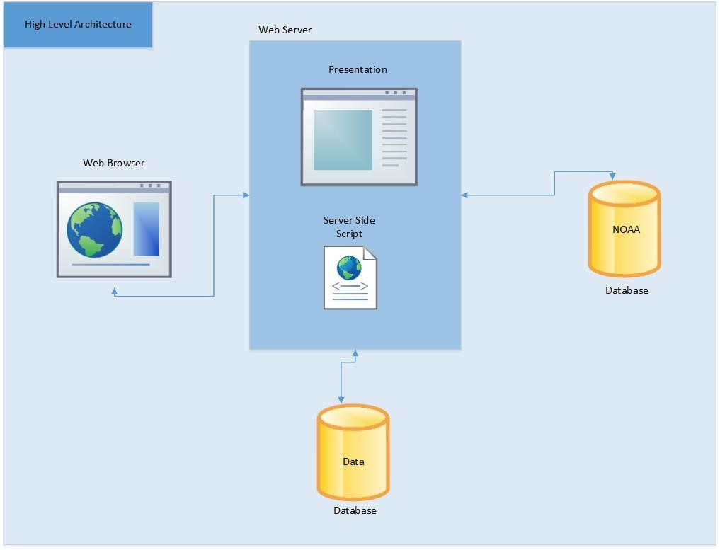

Figure 1: High Level Architecture

To estimate the time need for the overall project it has been divided into four parts. The first part is to complete the displaying of the evaporation rate and graph. The next is to create login functionality. The third thing is to add the notification system. Following that, ways of viewing statistical information about the site would be created.

Milestones:

Display Evaporation Rate

Account

Notifications

Statistical Data

Total = 107 person hours

# Resources

Table 1: Resources

|  |  |  |
| --- | --- | --- |
| **Resource needed** | **Reason** | **Date needed** |
| Server | For web application and database | 11/10/14 |
| ITS | Consultation for any security procedures needed to be followed | 11/10/14 |
| Anne Werner | Deciding on the final value of what will be considered a concrete pour with no risks, some risk, or major risks | 10/20/14 |

# Scheduling

Holidays / Breaks:

Thanksgiving Break - 11/24/14 - 11/31/14

Winter Break - 12/12/14 - 1/12/14

Spring Break - 3/9/14 - 3/15/14

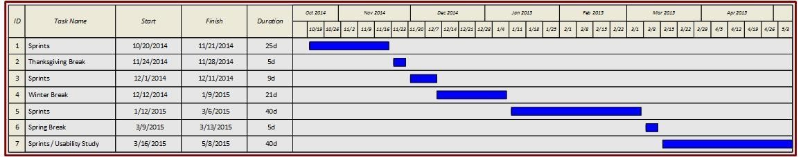

**FIGURE 2: SCHEDULE**

Sprints:

1. Code the user notifications db (userID, zipcode, time, Mar 16 lastEvapRate)
   1. When a notification is added, add zipcode to the global projects db if not in there
   2. Update data from global projects db
   3. Send notification on change of lastEvapRate
2. Code the global projects db (zipcode, time, other weather data) Mar 30
   1. Update every zipcode periodically (hour, 3 hours?)
3. Create admin UI Apr 13
   1. Display usage statistics
4. Empty Sprint for any added requirements Apr 27

# Communication

In addition to using Bitbucket, we will be using Dropbox for some file management. Also, we use Google Hangouts for group communication, and TeamViewer to look over documents and edit them while we are not altogether. To communicate with our customer we use email, and provide updates after each sprint. We also show working prototypes when available.

# Quality Assurance

There are no more risks.

SEE Test Plan Document

# Exit Strategy

## 425 Exit Strategy

Our teams exit strategy is to have a core component finished. That core component will have the functionality to be able to enter a location then having a web service gather weather data from NOAA for every hour for the next seven days. Then for each hour perform the calculation to determine the evaporation rate which determines the probability that concrete shrinkage cracks will form. This data will then be presented in a line graph. The line graph will have 3 colors red, yellow, and red where red has the highest risk, yellow has a moderate chance, and green means minimal/no chance of shrinkage cracks to form. The line graph will have different views such as week view and day view and specific weather data that was used for a calculation will be able to be seen by clicking on the line graph for a specific hour of the day.

## 499 Exit Strategy

The second semester exit strategy includes tests and demonstrations. When implementing the rest of the requirements (Create a database, create/edit/delete an account, forgot password, add/edit/delete notification, add/modify/delete project, and web site usage data) we will perform performance and system testing on notifications to determine if weather data is being updated correctly when needed and if the notifications is correctly notifying the user. Also, we will perform compatibility testing to make sure that for the 3 major browser the software works correctly and looks similar on each browser.

After the rest of the requirements are done being implemented we will perform installation testing. One of the last things we do is perform acceptance testing which will determine if the client accepts the software and all of the clients requirements are met and satisfied. Guides will then be made on how to view the web site usage statistics by using the admin account.